**Comprehensive and TPL**

Initially we are starting with three insurance companies

* Al Wathba
* Dar Al Takaful
* Tokio Marine

**TPL:**

As normally TPL have more or less same rate with all insurance provider we have to look which insurance provider is giving us best commission. For TPL we will go with Al Wathba as from Al Wathba we can avail up to 30% of discount provided NCC (no claim cerficate) – (10% for 1st year, 15% for 2years & 20% for 3 years). Additional discount can be provided for renewal. We can provide additional discount from our side also.

We can use an option of Dar al Takaful & Tokio Marine for comparison

Flow chart of Al Wathba, Dat Al Takaful & Tokip Marine TPL rates is as follows

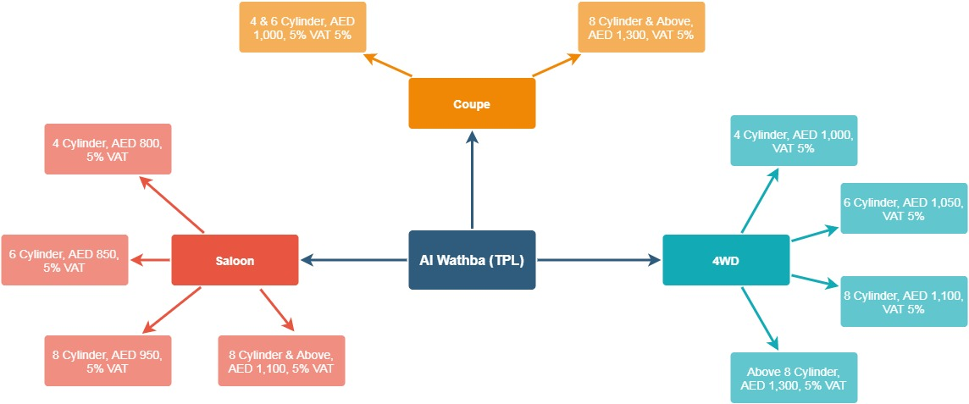

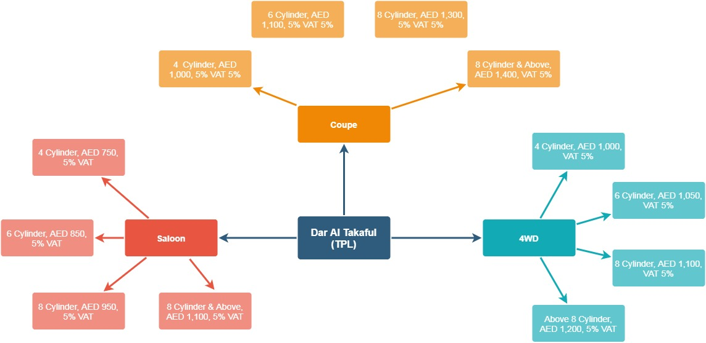

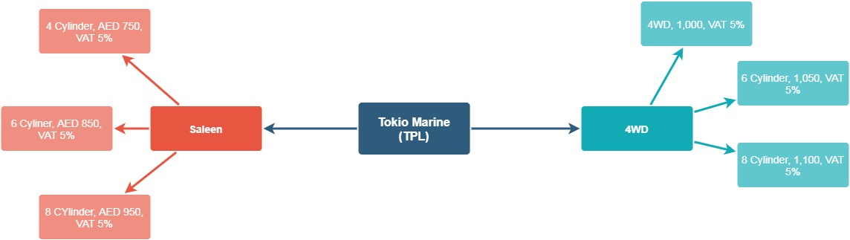

**Comprehensive:**

For comprehensive insurance we will go with Dar al Takaful or with Tokio Marine.

There are additional loading in some cases as well as additional discount. These are mentioned in attached TOB.

Find below flow chart for comprehensive insurance premium calculation for Dar al Takaful & Tokio Marine

